**GUI Prog. For Add two no.**

**Using Built-in Functions**

Dim a, b, c As Integer

a = InputBox("Enter No.1")

b = InputBox("Enter No.2")

c = a + b

MsgBox("Sum is " & c)

**Using UI**

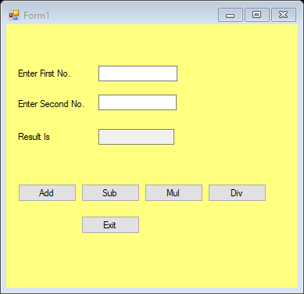

Public Class Form1

Dim a, b As Integer

Private Sub Button1_Click(ByVal sender As System.Object, ByVal e As System.EventArgs) Handles Button1.Click

a = TextBox1.Text

b = TextBox2.Text

TextBox3.Text = a + b

End Sub

Private Sub Button2_Click(ByVal sender As System.Object, ByVal e As System.EventArgs) Handles Button2.Click

a = TextBox1.Text

b = TextBox2.Text

TextBox3.Text = a - b

End Sub

Private Sub Button3_Click(ByVal sender As System.Object, ByVal e As System.EventArgs) Handles Button3.Click

a = TextBox1.Text

b = TextBox2.Text

TextBox3.Text = a * b

End Sub

Private Sub Button4_Click(ByVal sender As System.Object, ByVal e As System.EventArgs) Handles Button4.Click

a = TextBox1.Text

b = TextBox2.Text

If b = 0 Then

TextBox3.Text = "Can not div by Zero"

Else

TextBox3.Text = a / b

End If

End Sub

Private Sub Button5_Click(ByVal sender As System.Object, ByVal e As System.EventArgs) Handles Button5.Click

End

End Sub

End Class